Analog Engine
Technical Topics
This document provides some insights into an analog engine including some tricks and hints for its usage.
Author: Dietmar Hiller
License: CC BY-NC-SA 4.0 (https://creativecommons.org/licenses/by-nc-sa/4.0/ )

Version History
‍2024-12-14 | Better understanding of sine/cosine | Dietmar Hiller
‍2024-07-05 | Partial differential equations; Added capacitance of THAT integrators; building additional integrators | Dietmar Hiller
‍2024-02-25 | Helper: Limit Integral to positive values;  Scaling by analyzing the differential equation | Dietmar Hiller
‍2024-02-16 | Helper-Functions, sine-cosine generation | Dietmar Hiller
‍2024-02-05 | Intro to solving differential equations and integrals  Added root-calculation  Details about diodes and Z-diodes | Dietmar Hiller
‍2024-01-31 | License: CC BY-NC-SA 4.0 | Dietmar Hiller
‍2024-01-20 | Added Open Amplifier, Division  Explained sign of integrator | Dietmar Hiller
2024-01-12 | First version based on “Application Examples”  Timing topics | Dietmar Hiller
Table of Content
Version History 1
Applications 2
Solving differential equations 2
Partial differential equations 2
Calculating Integrals 4
THAT 4
Time constants 5
Sine function 5
Components 6
Diodes 6
Summer 7
Open Amplifier 8
Integrator 8
Building additional integrators 8
Z-Diodes 8
Scaling 9
By SI units 9
Time 9
Amplitude 9
By analyzing the differential equation 12
Helper Functions 12
Adjustable Value -1 to +1 12
Division x/y 12
Division, multiplication with a constant 13
Root (x) 13
sine(ωt) cosine(ωt) 14
Limit Integral to positive values 14

Applications

Solving differential equations
As example the differential equation is used. x’’ has to be integrated twice to get x(t), which is multiplied by -ω². The result is equal to x’’.
So, we assume x’’ to be known, integrate and multiply:
x’’ -> INTEGRATOR -> -x’
-x’ -> INTEGRATOR -> x
x -> COEFFICIENT -> -omega^2*x
Now, we have the right side of the equation and know it is equal to the left side x’’. Thus we can put those equal which is called the Kelvin feedback. The last line is
-omega^2*x -> x’’
Note, in the current form the solution will be zero, thus an initial condition is needed to get a visible result.

Partial differential equations
This is an adoption of the application note “alpaca_23” from Anabrid [https://analogparadigm.com/downloads/alpaca_23.pdf] to show a simple and straightforward way to solve partial differential equations.
It is based on the one-dimensional wave equation:

Since an analog computer only has time as a free variable, a straightforward way to machinize a problem like this is to approximate the differential quotient as a quotient of differences thus discretizing space

Setting n := 2 and λ:= 1 to simplify things further yields

with δ(t) being an impulse occurring at t = 0.

#coefficient(1): f1 # fix to 0.2 to get 2 for the integration
#coefficient(2): f2 # fix to 0.2 to get 2 for the integration
#coefficient(5): 1 -> delta_t
+1 -> coefficient.5 -> delta_t
#u_0 = delta_t
delta_t -> u_0
#coefficient(6): 0 -> u_3
GND -> coefficient.6 -> u_3

u_0, 10*:-f1u_1, u_2 -> integrator -> -u'_1 # input is u''_1
-u'_1 -> integrator -> u_1
u_1 -> inverter -> -u_1
-u_1 -> coefficient.f1 -> -f1u_1

u_1, 10*:-f2u_2, u_3 -> integrator -> -u'_2 # input is u''_2
-u'_2 -> integrator -> u_2

u_2 -> inverter -> -u_2
-u_2 -> coefficient.f2 -> -f2u_2

u_1 -> output.x
u_2 -> output.y

The result is a chaotic oscillation, which pattern is sensitive to the setting of the factor “2”. Channel 1 is u₁, channel 2 u₂ ,channel 4 the trigger.
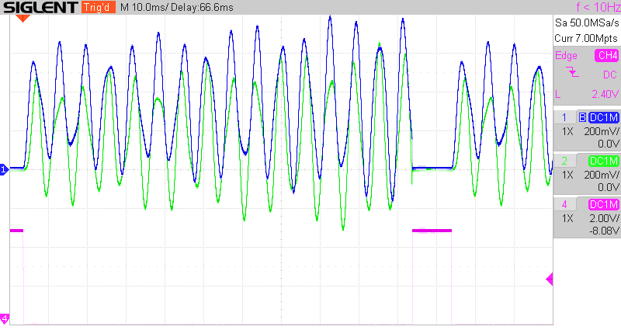

Calculating Integrals
As example, we are calculating .
E.g. for a=0,1, b=0,7 and c=0,6 we should find 0,144.
The corresponding AESL script is
+1 -> COEFFICIENT.1 -> a
+1 -> COEFFICIENT.2 -> b
# COEFFICIENT.3 is c

# obtaining x through integration of 1, starting at a
+1, IC:a -> INTEGRATOR -> -x

# limiting x to the upper limit of the integral b and set x=0 if beyond
A:-x, B:b, GT0:-x -> COMPARATOR -> -xl # to OUTPUT.X

# now performing the desired integration
-xl -> COEFFICIENT.3 -> -c*x # multiply by c
-c*x -> INTEGRATOR -> 1/2c*x^2 # to OUTPUT.Y

1/2c*x^2 reaches a maximum of 0,152 V, about 5% above the calculated value. Tuning the limits and the factor c visualizes the effect on the integral and the final value.
In the standard set-up, x rises from 0 to 1 in 1 ms, so very quickly. Putting all integrators to SLOW mode increases to 100 ms.

THAT
- Voltages
  - Signals +-10 V
  - RCA-OUT X,Y,Z,U: +-1 V
- Operating time:
  - REP : 0-10 s
  - REPF: 0-100 ms
- Operators
  - Capacitors
    - 100 pF
    - 100 nF (same as that of the integrator in feedback loop in SLOW mode)
  - Summer
    - Rf = 1 MOhm (feedback resistor)
    - Ri (1) = 1 MOhm
    - Ri (10)= 100 kOhm
  - Integrators
    - Capacitor: 1 nF
    - Capacitor in SLOW mode: 100 nF parallel to 1 nF => 99 nF
- Trigger
  - 5V TTL logic [0, 5V]
  - low level indicates operation
  - high level indicates halted or initial

Time constants
The integration time scale factor k0 of the integrators is given by the product of the resistance of the input and the capacitance of the feedback.
The “1” inputs have a resistance of 1 MOhm and those scaled by “10” of 100 kOhm.
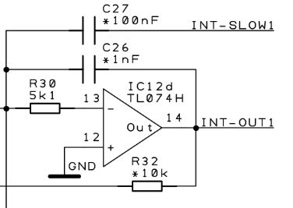
The capacitance is by default at 1 nF; by connecting SLOW to OUT a 100 nF capacitance can be put in parallel, increases the time scale factors of the respective integrator by a factor of approximately 100.
This gives the following time constant matrix for the speed of the integrator:
 |  |  |  | speed
 |  |  |  | normal |  | slow
 |  |  |  | C=1 nF | 1E-09 | C=100 nF | 100E-09
 |  |  |  | Time constant | ω [kHz] | Time constant | ω [kHz]
input | 1 | R=1 MΩ | 1E+06 | 1 ms | 6,2832 | 100 ms | 0,0628
 | 10 | R=100 kΩ | 100E+03 | 0,1 ms | 62,8319 | 10 ms | 0,6283

E.g. a time constant of 1 ms means that, if you connect a -1 signal to a “1” input, the output will ramp from 0 to 1 machine unit in 1ms.

Sine function
In order to investigate the effect of the time constant on the output of an analog engine, a sine function was used.
It is generated by solving the differential equation
,
which has as one solution

Here, we set a0=v0=x0=0 for simplicity.
The THAT program looks like:
+1 -> Coefficient.1 -> I0
x’’ -> Coefficient.6 -> xs’’
xs’’ -> Integrator -> -x’
-x’ -> Coefficient.7 -> -xs’
-xs’, IC: I0-> Integrator -> x
x -> Inverter -> -x
-x -> Coefficient.5 -> -omega^2*x=x’’ # omega squared
-omega^2*x -> x’’
The coefficients 6 and 7, and thus xs’’ and xs’, have been introduced to allow to multiply x’’ and x’ by 0,1 when a 10x input of the integrator is used in order to maintain the intended value.
The entire measurement matrix is included in this file:
The conclusion in summary,
- The 10x inputs speed up the integration. This has no effect on the frequency (omega) nor the amplitude of x’ and x.
- using SLOW divides the factor omega² by 100 per integrator used, thus the frequency is divided by root(100)=10.
- SLOW on the first integrator has no influence on the amplitudes of x’ and x.
- However, SLOW on the second integrator, additionally to the effect caused by the change of omega on x’ also multiplies the amplitude of x’ by 100.
  - I have not yet understood the mathematical reason behind this.

Components

Diodes
The diodes in THAT are BAS170W Schottky diodes.
+1, IC:-1 -> INTEGRATOR -> -x # generating ramp -1 .. +1
-x -> INVERTER -> x # to OUTPUT.X
AN: x -> DIODE -> y # to OUTPUT.Y
or
CAT:x -> DIODE -> y # to OUTPUT.Y

Characteristics:
The first image shows the input ramp from -1 V to +1 V and the output of the diode. Also visible is the trigger on the bottom line. The second image shows the output of the diode as function of the input.
- Forward (anode to cathode):
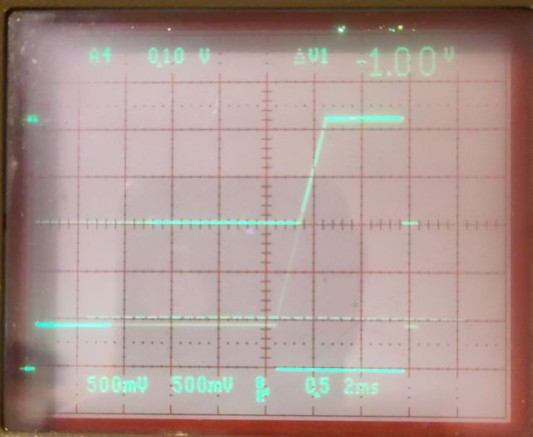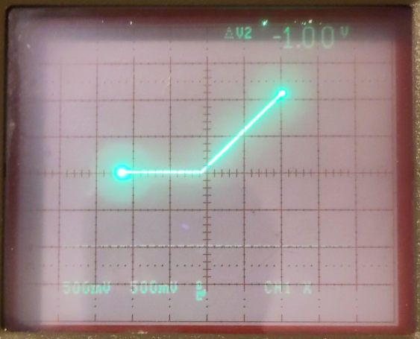
- Backward (cathode to anode):
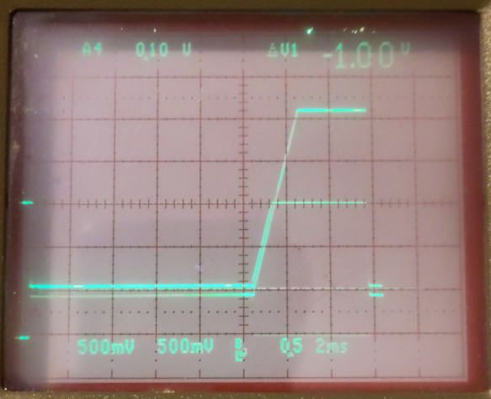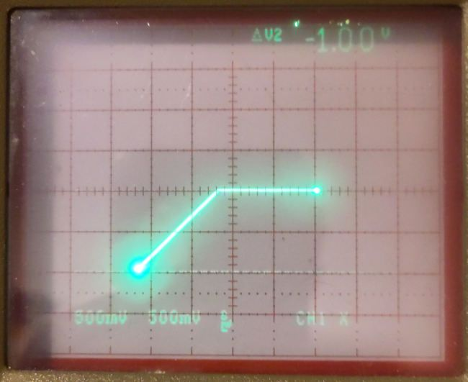
Note the diodes have a forward voltage drop of about 0.03 machine units, thus cannot be used as limiters where the cut-off has to be precisely at zero.

Summer
Note that the summer is inverting the sign.
Ports:
- IN:
- SJ
- OUT
- FB
- GND

Open Amplifier
Some advanced functions can be realized with an open amplifier, i.e. an amplifier without feedback loop.
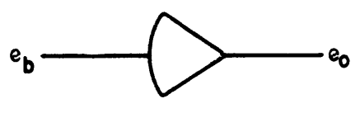
On THAT this is realized by connecting FB of a SUMMER to GND directly below.
FB:GND, input -> SUMMER -> output

Integrator
Note that the integrator is inverting the sign and that the initial condition has the same sign as the input.

Building additional integrators
Because the construction of the integrator is
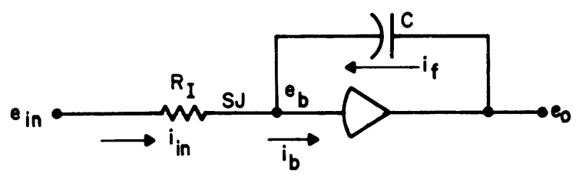
it can be build up with an open amplifier.
FB:GND, SJ:cap-output, integrand -> SUMMER -> integral
integral -> capacitor.100nF -> cap-output

Note:
- this integrator has 100 nF in the feedback loop, thus all integrators in the application also have to use 100 nF (thus running in SLOW mode).
- the capacitor is not re-set during the IC cycle in repetitive mode. Only continuous mode is possible. Resetting is done by turning THAT OFF and restart again.
- an initial condition cannot be set

Z-Diodes
The Z-Diodes in THAT are BZT52HC10.
- Forward: same as diodes
- Backward
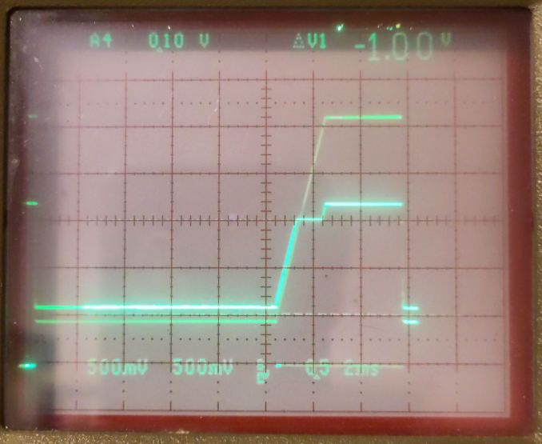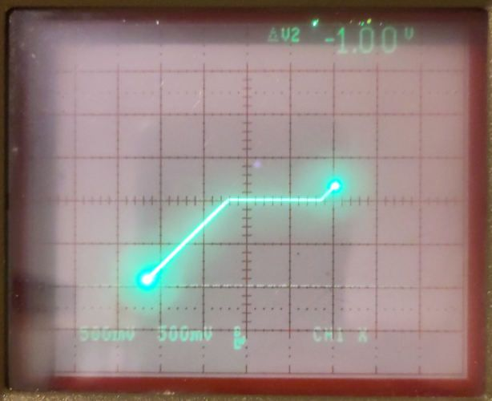

Scaling

By SI units

Time
The time scale of the analog engine is governed by the time constant of the integrators. One time unit of the algorithm corresponds to the time constant (the timebase) of the engine.
For the Anabrid-THAT input resistance is 1 MΩ and the capacitance 1 nF, giving a time constant of 1 ms. This means that 1 ms of the engine corresponds to 1 time-unit of the calculation, which is 1 s if SI units are used for all variables and parameters.
To analyze a problem, this time-unit may be too slow or too fast. Thus scaling is necessary. Scaling time can be performed by describing the problem in terms of a different time unit, e.g. years for demographic applications or nano-seconds for electronic ones.

Amplitude
All values of an analog engine always have to fall in the interval [-1, +1].
This means that initial conditions and constants have to be scaled to the engine range. Also it has to be made sure that the system during operation does not exceed this interval.
The easiest way to do scaling is to use prefixes to the SI units, so e.g. centi f or 10⁻² or mega for 10⁶. Note that the entire algorithm has to be rewritten into these new units.
Best practice is to only use SI base units which are
- Meter (m) for length
- Second (s) for time
- Kilogram (kg) for mass
- Ampere (A) for electrical current
- Kelvin (K) for temperature
- Mol (mol) for amount of substance
- Candela (cd) for luminous intensity
This means that derived units should be re-written to their base units. For instance 1 N = 1 kg*m/s².
As an example, we may use the following data for the damped harmonic oscillator:
Initial Position | y0 | 1,5 m
Initial Speed | y0’ | -0,15 m/s
Spring Force | S | 2,5 N/m | kg/s²
Damping | D | 0,3 N/(m/s) | kg/s
Mass | m | 0,06 kg
 | 1/m | 16,667 kg⁻¹
Critical values are initial position (1,5 m) and 1/m (16,667 kg⁻¹). Spring force could be coped with by using a gain 10 input.
Please see the table below while following the description of the following steps.
First we take care of y0. We replace the length measured in meter with 10¹ meter, thus we make use of deca-meter. y0 and y0’ have to be adapted. See columns “deca-m” below. Spring Force and Damping remain unchanged because in base units the length gets canceled out.
Next issue is that 1/m is well above 1. We are representing the weight by 10⁻² kg, so 10¹ grams (deca-g). See columns “deca-g”. This also influences spring force and damping, which now exceed our target range.
Now, the second is replaced by 10⁻¹ (deci-s) seconds resulting in the columns “deci-s”. Note that this also performs time-scaling, so that one time-unit of the analog engine now corresponds to one deci-second instead of one second before.
After the last scaling we have the issue that y0’ is very close to zero. There are more advanced scaling techniques which manage to optimize the value range of each operational amplifier. For instance the initial speed is converted to a value very close to zero, which is not the optimal. These can be found e.g. at
- “Analog computing using dynamic amplitude scaling and methods of use”, patent US11120230B2 Yannis Tsividis at Sendyne Corp, September 2018
- “Analog Computing Technique” by Robert Paz, Mai 1999 (link)
- “Handbook of Analog Computing” by Electronic Associates Inc.
- “Automatic Analog Computer Scaling Using Digital Optimization Techniques” by John Celmer and Mary Rouland, NASA March 1970 (link)

By analyzing the differential equation
In cases where e.g. two parameters with the same unit show very different changes, adapting the SI unit is not possible. Here, analyzing the differential equation together with the application can provide a viable solution. For an example see the application “Falling Mass” in the document “Example Applications”.
The set of differential equation is

z is in the order of 100 m whereas x and y are in some cm.
The solution is to measure z, ż and z˙˙ in a unit of 100 m and to remain with the other values in m. Here ż is needed to calculate x˙, so ż has to be multiplied by 100 to convert to m, which can be done by the coefficient b. Also x˙ has to be converted to 100 m by dividing a by 100.
Finally, z is measured in 100 m and x and y in m.

Helper Functions

Adjustable Value -1 to +1
While the connection of a coefficient potentiometer to the machine units supply gives an adjustable value in a range of either [−1, 0] or [0, +1], this function offers an adjustable value within the entire machine unit range of [−1, +1]. It is given by “+1-2*C1”.
Note, the summer is negating the output.
-1 -> Coefficient.1 -> variable
+1, variable, variable -> Summer.1 -> output

Division x/y
A division (x/y) can be realized with a multiplier in the return path of an open amplifier:
x, OA -> OPEN-AMP -> -x/y
-x/y, y -> MULTIPLIER -> OA

Division, multiplication with a constant
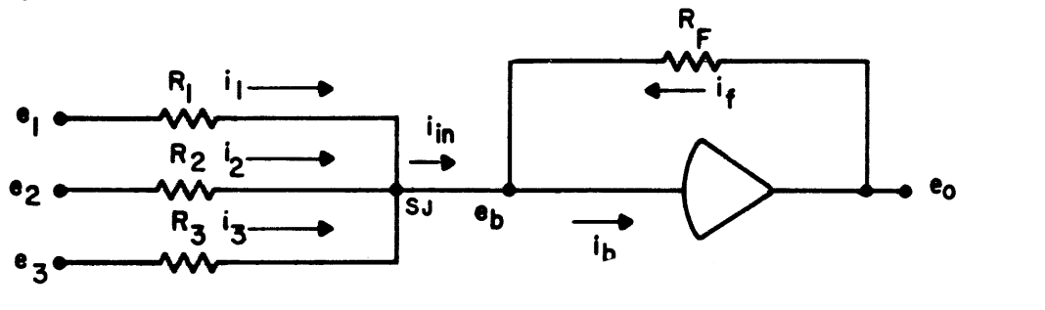
Some basics first [1]:
- SUMMER:

  - Thus reconnecting e_{o} to e_{i} puts R_{i} in parallel to R_{F} resulting in a new R_{F} of .
  - R_{F}=R_{i} for an input weight of 1, R_{F}=1/10 R_{i} for 10.
- OPEN-AMP
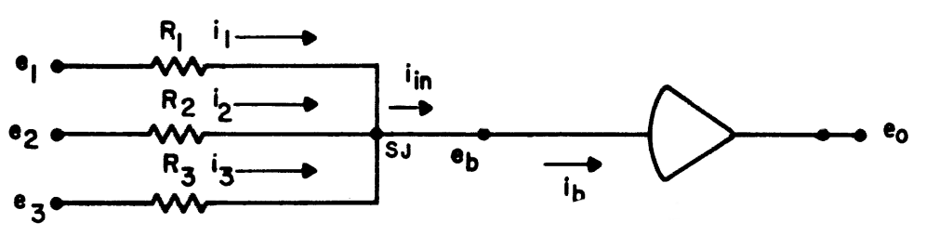
  - Reconnecting e₀ to e_{i} as above creates a SUMMER with R_{i} as R_{F}.

- Division by 10
1:x, 10:-x/10 -> OPEN-AMP -> -x/10
  - measured was a division by 10,567; a >5% error
  - a second feedback loop divides additionally by 2 and so on
- Division by 2
x, y, -(x+y)/2 -> SUMMER -> -(x+y)/2
  - a second feedback loop divides by 3 and so on
- Division by C<1
x, y, OA1 -> OPEN-AMP -> -(x+y)/c
-(x+y)/c -> COEFFICIENT.C -> OA1
- Multiplication by 2: x, x -> SUMMER -> -2x
- Multiplication by 2*C
(useful if the Coefficient should be >1 but the following calculations are still <1):
x -> COEFFICIENT.C -> C*x
C*x, C*x -> SUMMER -> -2C*x
- Multiplication by 10: 10:x -> SUMMER -> -10x

Root (x)
root (-x) can be calculated in a similar way as the division. Note: the input has to be negative.
A:-x, LT0:-x -> COMPARATOR -> -xLimited
-xLimited, OA -> OPEN-AMP -> root(x)
root(x), root(x) -> MULTIPLIER -> OA
The first command makes sure that the input is never positive, because this puts the circuit into an error, resulting in an error, which only can be reset by un- and re-plugging the inputs of the multiplier. This is also the case when the operation mode has changed, e.g. from OFF to REP.

sine(ωt) cosine(ωt)
sin(ωt) and cos(ωt) are generated through solving the differential equation .
There are 2 possibilities: If only the sine is required, the equation can be coded as given, i.e. with ω² in the feedback loop.
f’’ -> integrator -> -f’
-f’ -> integrator -> f
-1 -> coefficient.amplitude -> IC # amplitude of cos
f -> coefficient.omega^2 -> omega^2*f
omega^2*f -> inverter -> -omega^2*f
-omega^2*f -> f’’
f -> out.x # cos

If however e. g. a conversation from polar coordinates to Cartesian is required, the coding has to look as follows:
f’’ -> integrator -> -f’
+1 -> coefficient.amplitude -> IC
-f’ -> inverter -> f’
-f’ -> coefficient.omega_cos -> -omega*f’
-omega*f’ -> integrator -> omega*f
omega*f -> inverter -> -omega*f
-omega*f -> coefficient.omega_sin -> -omega^2*f
-omega^2*f -> f’’
f’ -> out.x # cos
omega*f -> out.y # sin

Limit Integral to positive values
To limit the output to positive values use [2]
input-variable, SJ:limiter -> INTEGRATOR -> result
CAT:result -> DIODE -> limiter
NB: This does not limit to values >= 0 entirely. Due to the response function of the diode a small negative value remains.
Literaturverzeichnis
1: Electronic Associations Inc., Handbook of Analog Computing, 1971
2: Michael Koch, THAT Analog Computer Book, 2024, http://www.astro-electronic.de/THAT_Analog_Computer_Book.pdf

